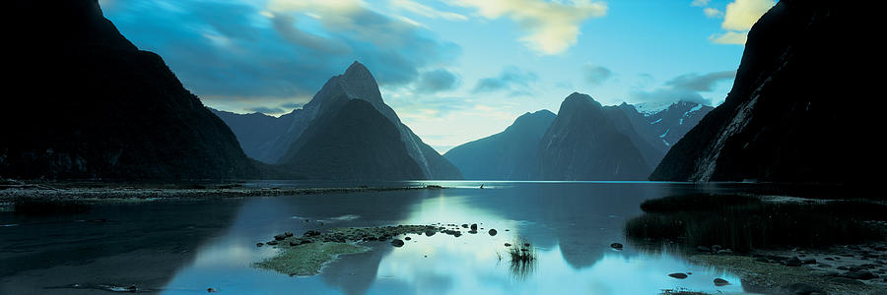

**13-Day New Zealand**

**Royal Princess**

**December 2 – 15, 2023**

--------------------------------------------------------------------------------------------------------------------------------

TOUR PLAN INTERNATIONAL GROUP RATE PRICING:

$400 Deposit

dOUBLE sINGLE

Balcony (Cat BB) $1,819.00 $3,638.00

Mini Suite (Cat MF) $2,089.00 $4,178.00

Taxes & Fees $311.70

Gratuites $209.50

Transfers $38.00 Round trip

*Please note that prices are listed per person, non-air cruise-only and based on double occupancy.



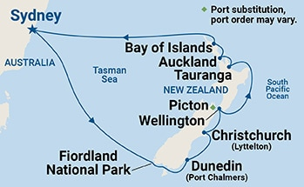

### **13 Days | 6 Ports | 1 Scenic Cruising**

|  |  |  |  |
| --- | --- | --- | --- |
| Date | Port | Arrive | Depart |
| Sat, Dec 2Saturday, December 2nd 2023 | Sydney, AustraliaView excursions in Sydney, Australia on Saturday, December 2nd 2023 |  | 04:00 pm |
| Sun, Dec 3Sunday, December 3rd 2023 | At SeaView onboard experience  for Sunday, December 3rd 2023 |  |  |
| Mon, Dec 4Monday, December 4th 2023 | At SeaView onboard experience  for Monday, December 4th 2023 |  |  |
| Tue, Dec 5Tuesday, December 5th 2023 | Fiordland National Park (Scenic Cruising)View excursions in Fiordland National Park (Scenic Cruising) on Tuesday, December 5th 2023 | 07:00 am | 04:00 pm |
| Wed, Dec 6Wednesday, December 6th 2023 | Dunedin (Port Chalmers), New ZealandView excursions in Dunedin (Port Chalmers), New Zealand on Wednesday, December 6th 2023 | 12:45 pm | 09:00 pm |
| Thu, Dec 7Thursday, December 7th 2023 | Christchurch (Lyttelton), New ZealandView excursions in Christchurch (Lyttelton), New Zealand on Thursday, December 7th 2023 | 10:00 am | 08:00 pm |
| Fri, Dec 8Friday, December 8th 2023 | Wellington, New ZealandView excursions in Wellington, New Zealand on Friday, December 8th 2023 | 08:00 am | 06:00 pm |
| Sat, Dec 9Saturday, December 9th 2023 | At SeaView onboard experience  for Saturday, December 9th 2023 |  |  |
| Sun, Dec 10Sunday, December 10th 2023 | Tauranga, New ZealandView excursions in Tauranga, New Zealand on Sunday, December 10th 2023 | 06:30 am | 05:30 pm |
| Mon, Dec 11Monday, December 11th 2023 | Auckland, New ZealandView excursions in Auckland, New Zealand on Monday, December 11th 2023 | 06:30 am | 07:00 pm |
| Tue, Dec 12Tuesday, December 12th 2023 | Bay of Islands, New ZealandView excursions in Bay of Islands, New Zealand on Tuesday, December 12th 2023  ( Water Shuttle Required, Wheelchair Access Limited ) | 07:00 am | 05:00 pm |
| Wed, Dec 13Wednesday, December 13th 2023 | At SeaView onboard experience  for Wednesday, December 13th 2023 |  |  |
| Thu, Dec 14Thursday, December 14th 2023 | At SeaView onboard experience  for Thursday, December 14th 2023 |  |  |
| Fri, Dec 15Friday, December 15th 2023 | Sydney, AustraliaView excursions in Sydney, Australia on Friday, December 15th 2023 | 06:00 am |  |

### **Royal Princess®**

From its breathtaking piazza-style Atrium to the dramatic views from the glass-floored SeaWalk®, Royal Princess is sure to delight. Relax at The Sanctuary, a tranquil haven reserved for adults, watch the mesmerizing Princess WaterColor Fantasy light and water show, or dine on tantalizing cuisine at venues like Crown Grill and more.

* Last Refurbished: December 2018
* Guest Capacity: 3,560 lower berths
* Number of Crew: 1,346
* Tonnage: 142,229

### **Dining**

Passionate about our culinary craft, we’re committed to serving you mouthwatering, handcrafted dishes made from scratch throughout your voyage. Be sure to join us at one of our award-winning specialty restaurants to celebrate your next birthday, anniversary or milestone and enjoy tantalizing specialties.

* Chef's Table Lumiere (fine dining experience)^
* Chocolate Journeys℠
* Sabatini's℠ (Italian)^
* Crown Grill℠ (steakhouse)^
* Alfredo's Pizzeria
* Horizon Court (buffet)
* Vines (wine bar)^
* International Café
* Crab Shack

**Mini Suite**

* Mini-suite accommodation featuring queen bed, wall-mounted flat-screen tv, sitting area with couch, desk with chair and telephone, balcony with table and chairs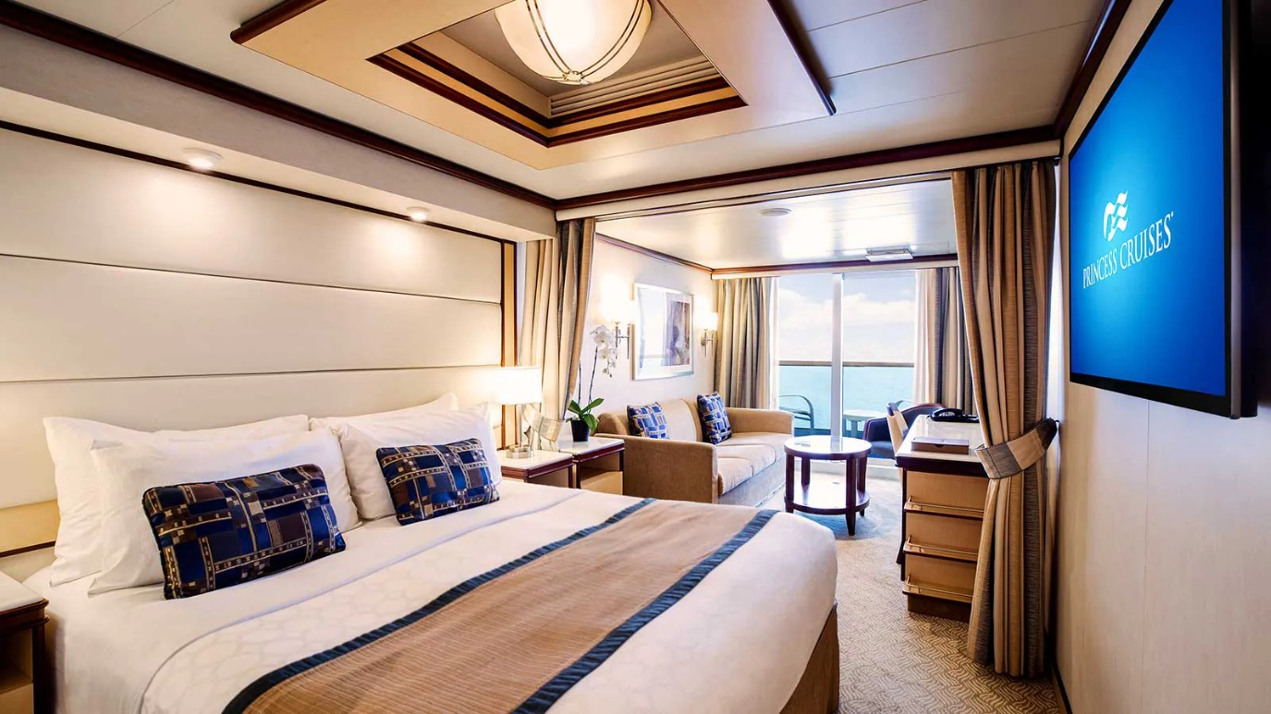

**Balcony**

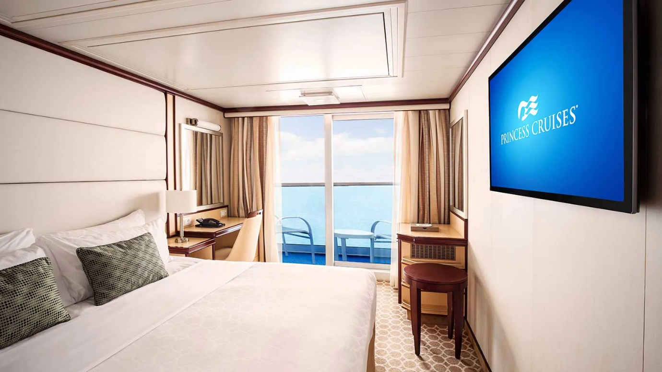

### **Activities**

Each day, a world of exciting activities awaits, from cooking demonstrations to dance classes, trivia contests and a range of enrichment programs, including our Encounters with Discovery at SEA™ speaker series from experts who offer insights into the places you’ll visit.

* Discovery at SEA™ Programs
* Festivals of the World
* The SeaWalk®
* Princess Live! (live television studio show)
* The Piazza
* Shops of Princess
* Art Gallery & Auctions
* Freshwater Pools & Hot Tubs
* Sports Court (basketball, volleyball, tennis)
* Lawn Court (golf putting and lawn games

### **Entertainment**

There’s always something happening on board — from heading to the Princess Theater for a lavish original musical production to enjoying a blockbuster movie poolside under the stars or simply relaxing in a lounge sipping a cocktail where a live band is playing your song.

* Movies Under the Stars®
* The Voice of the Ocean (live show)
* Princess® Watercolor Fantasy Show
* Original Musical Productions
* Music & Dancing
* Vegas-style Casino
* Featured Guest Entertainers
* Princess Theater
* Club 6 (dance club)
* Crooners Bar

### **Joyful Rejuvenation**

Everything you need to refresh body and mind is right on board. Indulge in a manicure, pedicure or a makeover in the salon, or a soothing massage in the Lotus Spa®. Or maybe it’s a brisk workout in the fitness center, followed by a little “me time” in The Sanctuary, a tranquil retreat reserved just for adults.

* The Princess Luxury Bed (on board in Feb. 2018)
* SLEEP by Princess
* The Sanctuary (retreat for adults)^
* Lotus Spa®^
* Lotus Spa® Fitness Center
* The Enclave® at Lotus Spa® (thermal suite)^
* Fitness Classes^